Mark Tattrie, Justen DePourcq, Braden D’eith, Matt Kearney, Karl Arreola – GROUP 16

**Kitty Cat Space Map Game Guide**

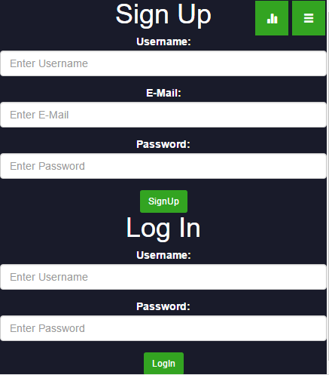**Sign-up/Log-in**

1. Click the User Icon. 
2. If you already have an account you can just log in but if you don’t, you can sign up for a new account. Logging in will take you to your profile.

**Main Gameplay**

1. From the main menu you can click launch to navigate to the course select page. 
2. 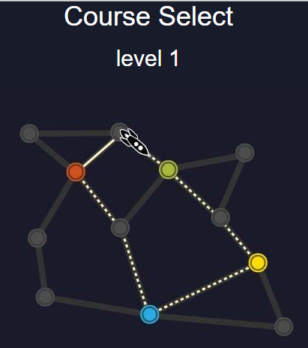Once you’re in the course select page, click the course image to start the game.
3. You will have a brief glimpse of the game board before a quick count down starts the game, loading the player and objectives.

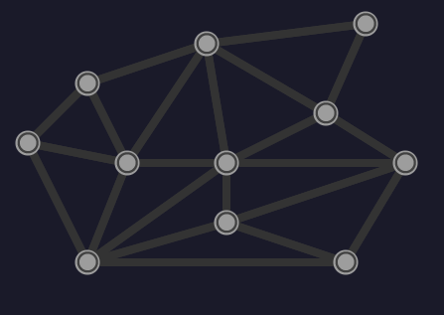 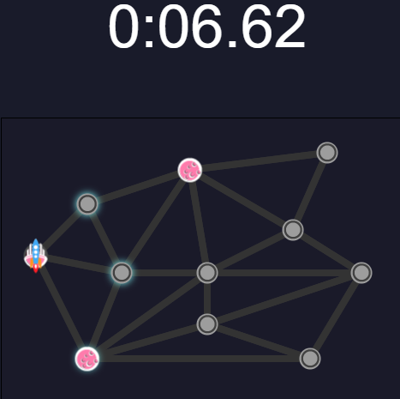

1. Your goal as the rocket ship is to visit each planet and return to the starting node as fast as you can. Upon completing the objective, a new set of objectives will appear for the player to complete. (Each level has 10 sets of objectives or challenges)
2. When you create your path, you can click back to a previous node to redo a step but the time still keeps counting and your overall time will be affected.
3. After completing the level, the game will take you to the results page showing the time it took for you to complete. It will also post your score to the leaderboard and update your profile if it is a new personal best.

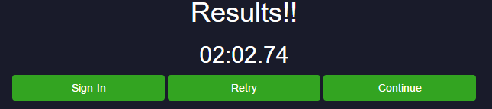

**Profile**

1. When you’re signed in you can access your profile page by clicking the user button. 
2. The profile page shows you the best times of each course you’ve done.

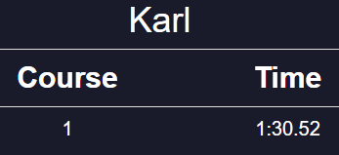

1. You can also click the logout icon to sign out of your account. 
2. The back button will navigate you back to the main menu. 

**Leaderboard**

1. You can access the Leaderboard by clicking the leaderboard icon. 
2. Username, Time, and Scores are posted in the Leaderboard.

**Settings**

1. First click on the menu button. 
2. 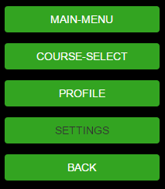Next, click on the settings button.
3. From here you can turn the background music and sound effects on or off. Each button will display the current status.

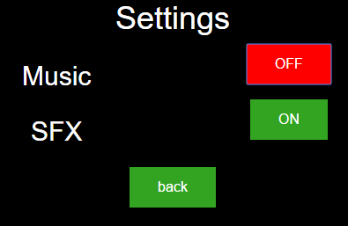

1. Hit the back button to return to the menu.